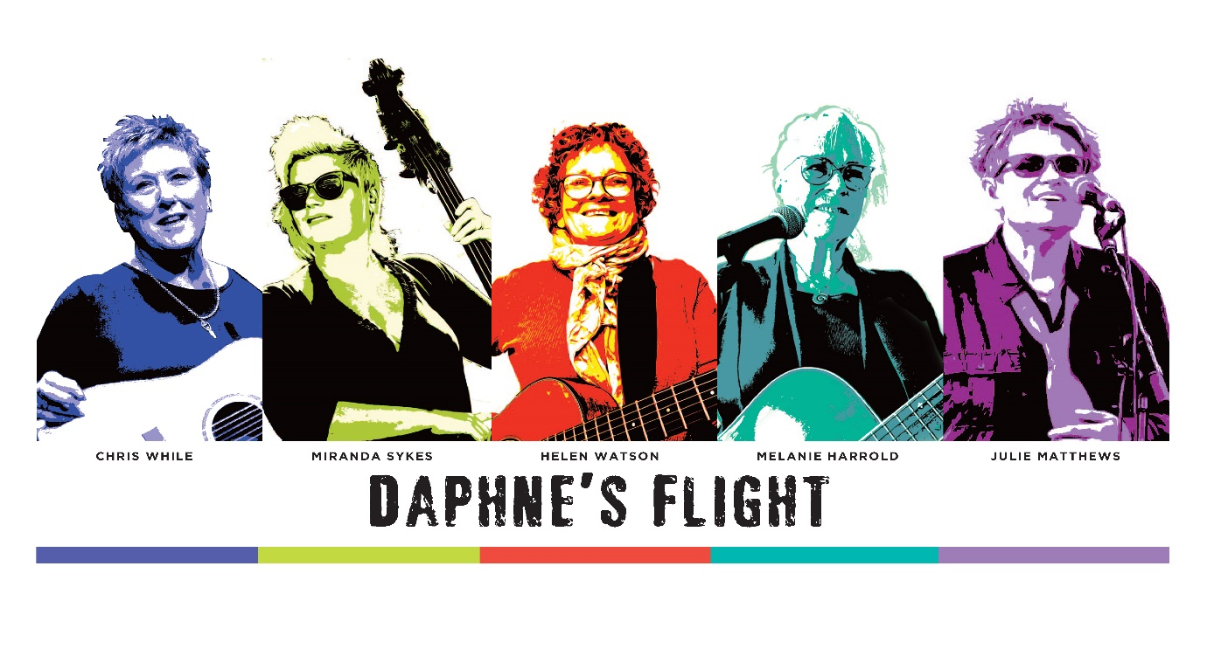
Challenges, changes and breaking new ground….

Daphne’s Flight are Chris While, Julie Matthews, Helen Watson, Melanie Harrold & Miranda Sykes

When Daphne’s Flight completed their last tour in 2018 and after a handful of euphoric festival performances in 2019 which garnered them an army of new followers, the stage was set for a 25th anniversary tour in 2020 with a brand new album to launch and celebrate.

Then the world turned upside down.

What followed were two frustrating years of postponed dates and a career sitting idle, unable to capitalise on the momentum that had been building since their 2017 reunion tour.

Now the heavy cloud of the pandemic has lifted and the stage is set for a euphoric return to touring for Daphne’s Flight. With a heavy heart, Christine Collister pulled out of the band for personal reasons at the beginning of 2022 so Chris, Helen, Julie and Mel asked Miranda Sykes (Show of Hands) to join the band. The result in rehearsals couldn’t be better, the blend of personalities and musical synergy has given new energy and hope to Daphne’s and so a new chapter begins.

Five individually successful solo artists in their own rights, together they create a unique and unparalleled force, empowering women of all ages, producing music that is relatable, moving and uplifting and creating a chemistry on stage that is both joyful and contagious.
Daphne’s Flight are on tour in May 2022.

www.daphnesflight.com

